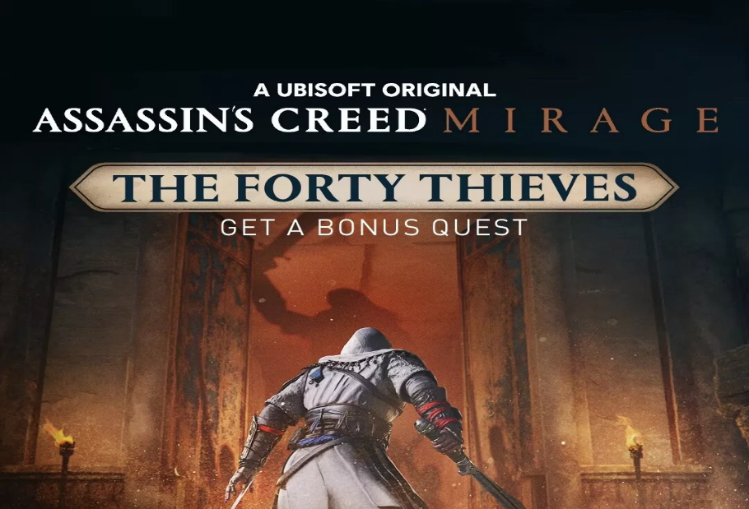

*Assassin’s Creed Mirage:*

1️. **Return to Classic Stealth-Based Gameplay**

* Focuses on **parkour, stealth assassinations, and strategic infiltration** games.
* Less emphasis on RPG elements, making it a **tighter, story-driven experience**.

2️. **Set in 9th-Century Baghdad**

* Features a **dense, lively city divided into four districts**, including **Karkh .**
* Explores **Alamut**, the legendary stronghold of the Hidden Ones (early Assassins).

3️. **Basim’s Origin Story**

* Follows **Basim Ibn Ishaq**, a street thief who joins the **Hidden Ones** to battle .
* Ties into his **mysterious past and visions**, setting up his role in Assassin’s.

4️. **New Game Plus & Permadeath Mode**

* **Post-launch update added a New Game Plus mode** for replayability.
* Introduces a **permadeath mode** called “Full Synchronization” for hardcore players.

5️. **Modern Enhancements with a Classic Feel**

* Uses the **Ubisoft Anvil engine** for better visuals and smooth performance.
* Includes **quality-of-life improvements**, while keeping the **classic Assassin’s.**